Connect AmazonRDS to SQL Server Management 2019

Follow link: https://www.youtube.com/watch?v=vWrChOXoGRE

Pre-requisites:

User accounts:

Username: surya.nupa@gmail.com

Password: (E9j:f.rfwBV67j

Username: pusamsaikumar302@gmail.com

Password: CJP@(k5W/(_NA)h

Data base Engine: endpoint and port 1433  
rsaecrsapisql2022.cbo8ouwquvxf.ap-south-1.rds.amazonaws.com

SQL Server Database:

Username: saikumar

Password: saikumarP123

Go to AWS Console:

Go to Amazon RDS console

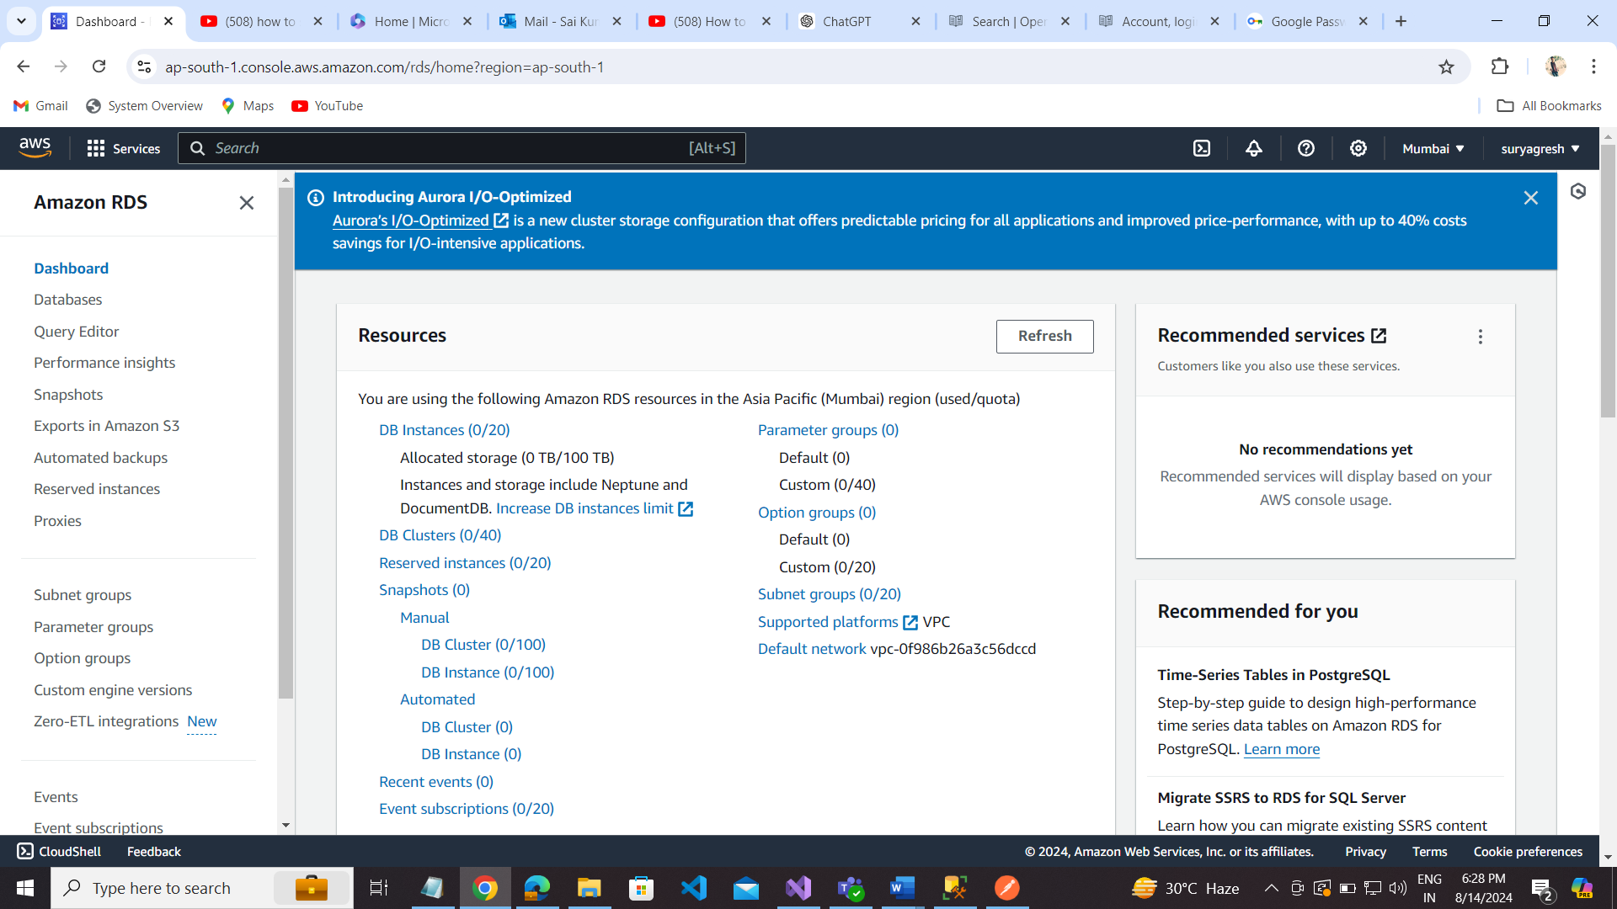

Go to Databases to create sql server connection to ms sql server 2019.  
To create Database:

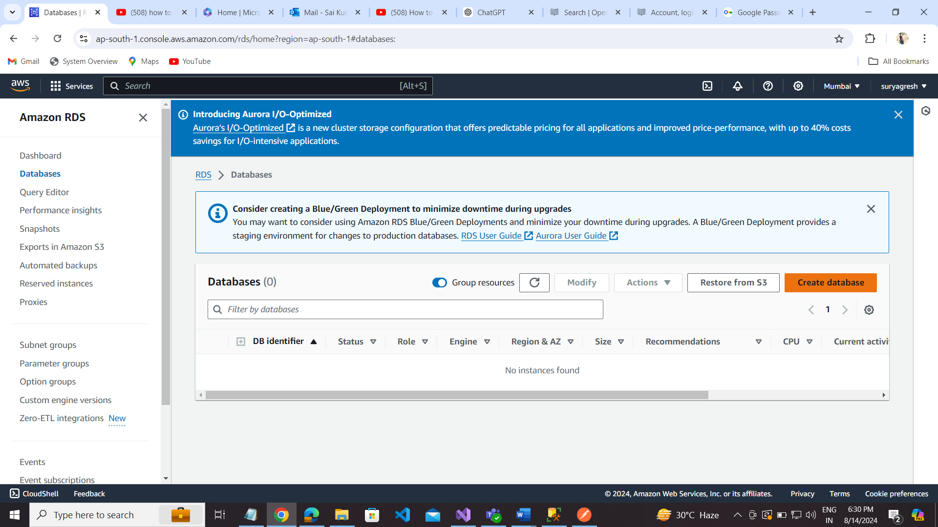

**Choose a database creation method:**

**Standard create**

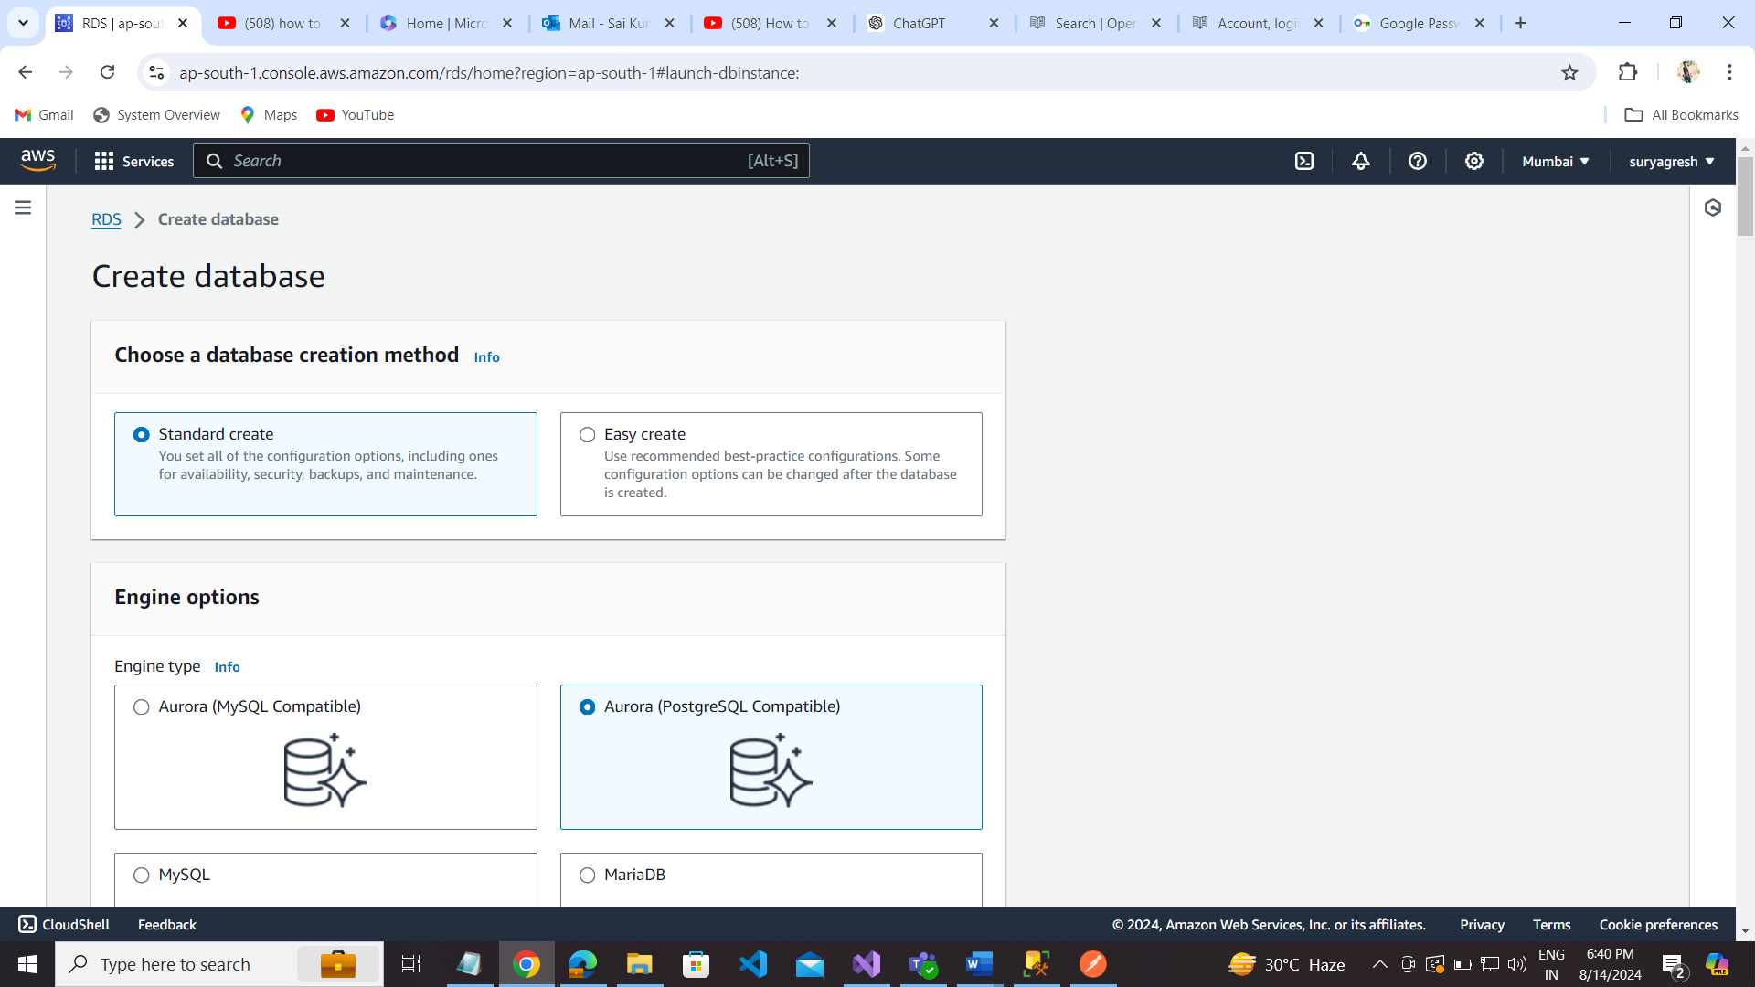

**Engine options:** Microsoft SQL Server

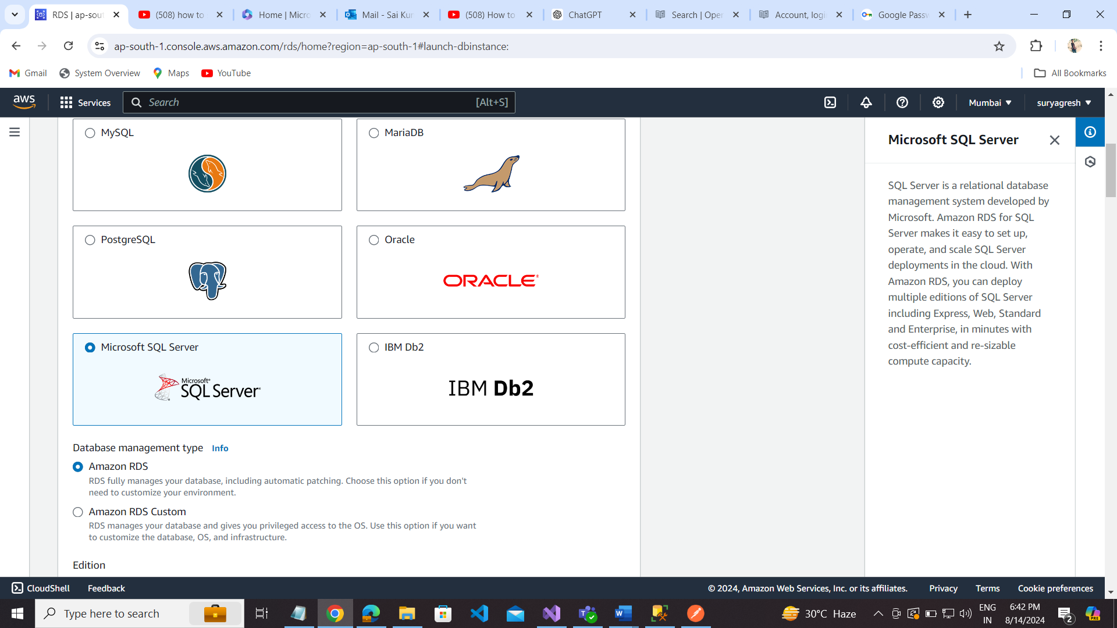

Database Management Type: Amazon RDS

Edition: SQL Server Standard Edition

Engine Version: SQL Server 2022 16.00.4131.v1

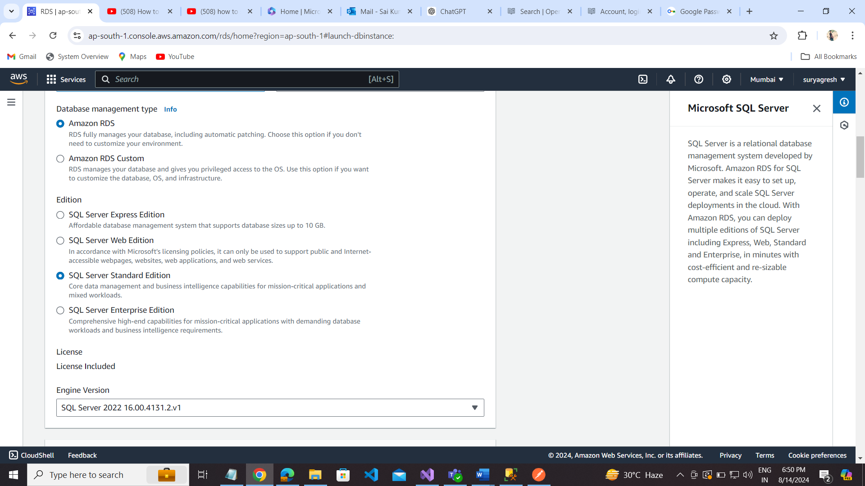

**Templates:** Dev/Test

**Settings:** DB instance identifier ---- rsaecrsapisql2022

**Credentials Settings:** Master username ----- saikumar

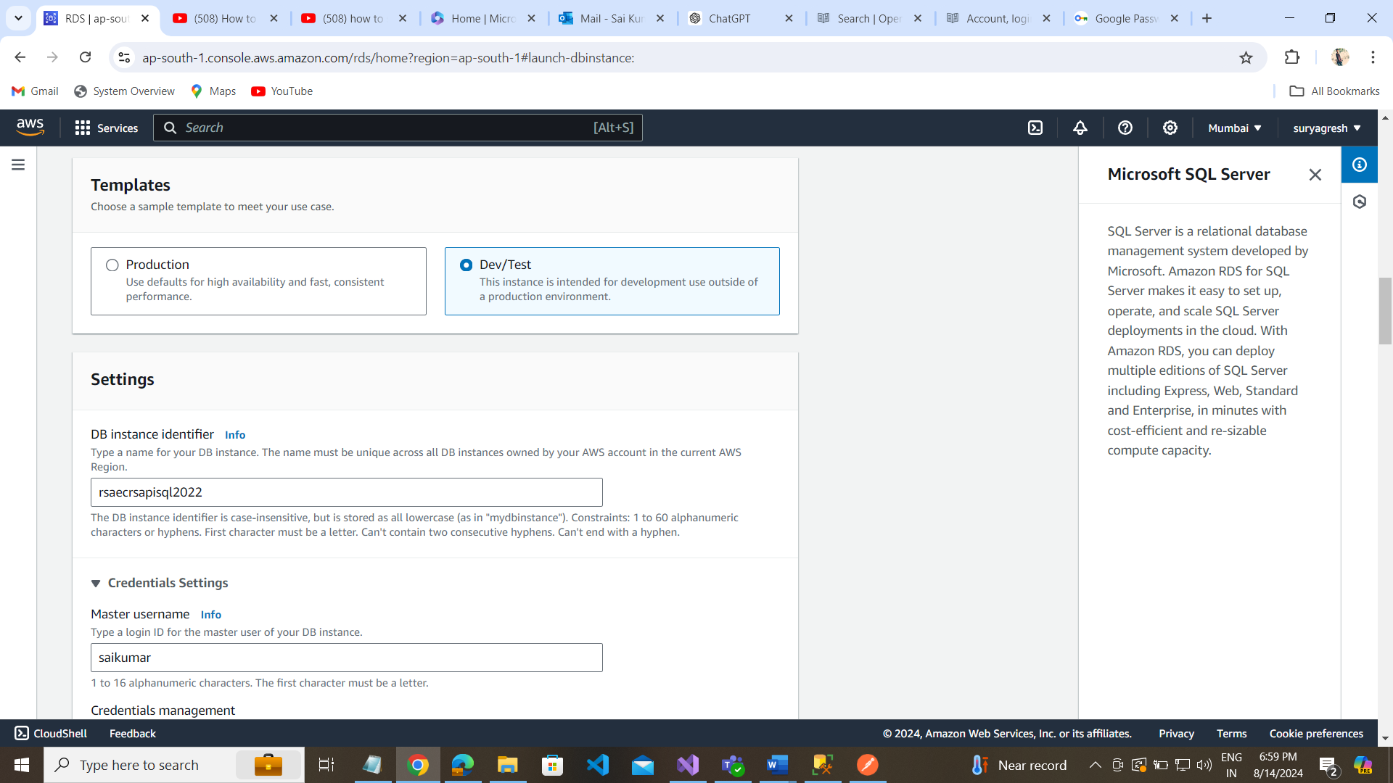

Credentials management: Self managed

Password: saikumarP123, ConfirmPassword:saikumarP123

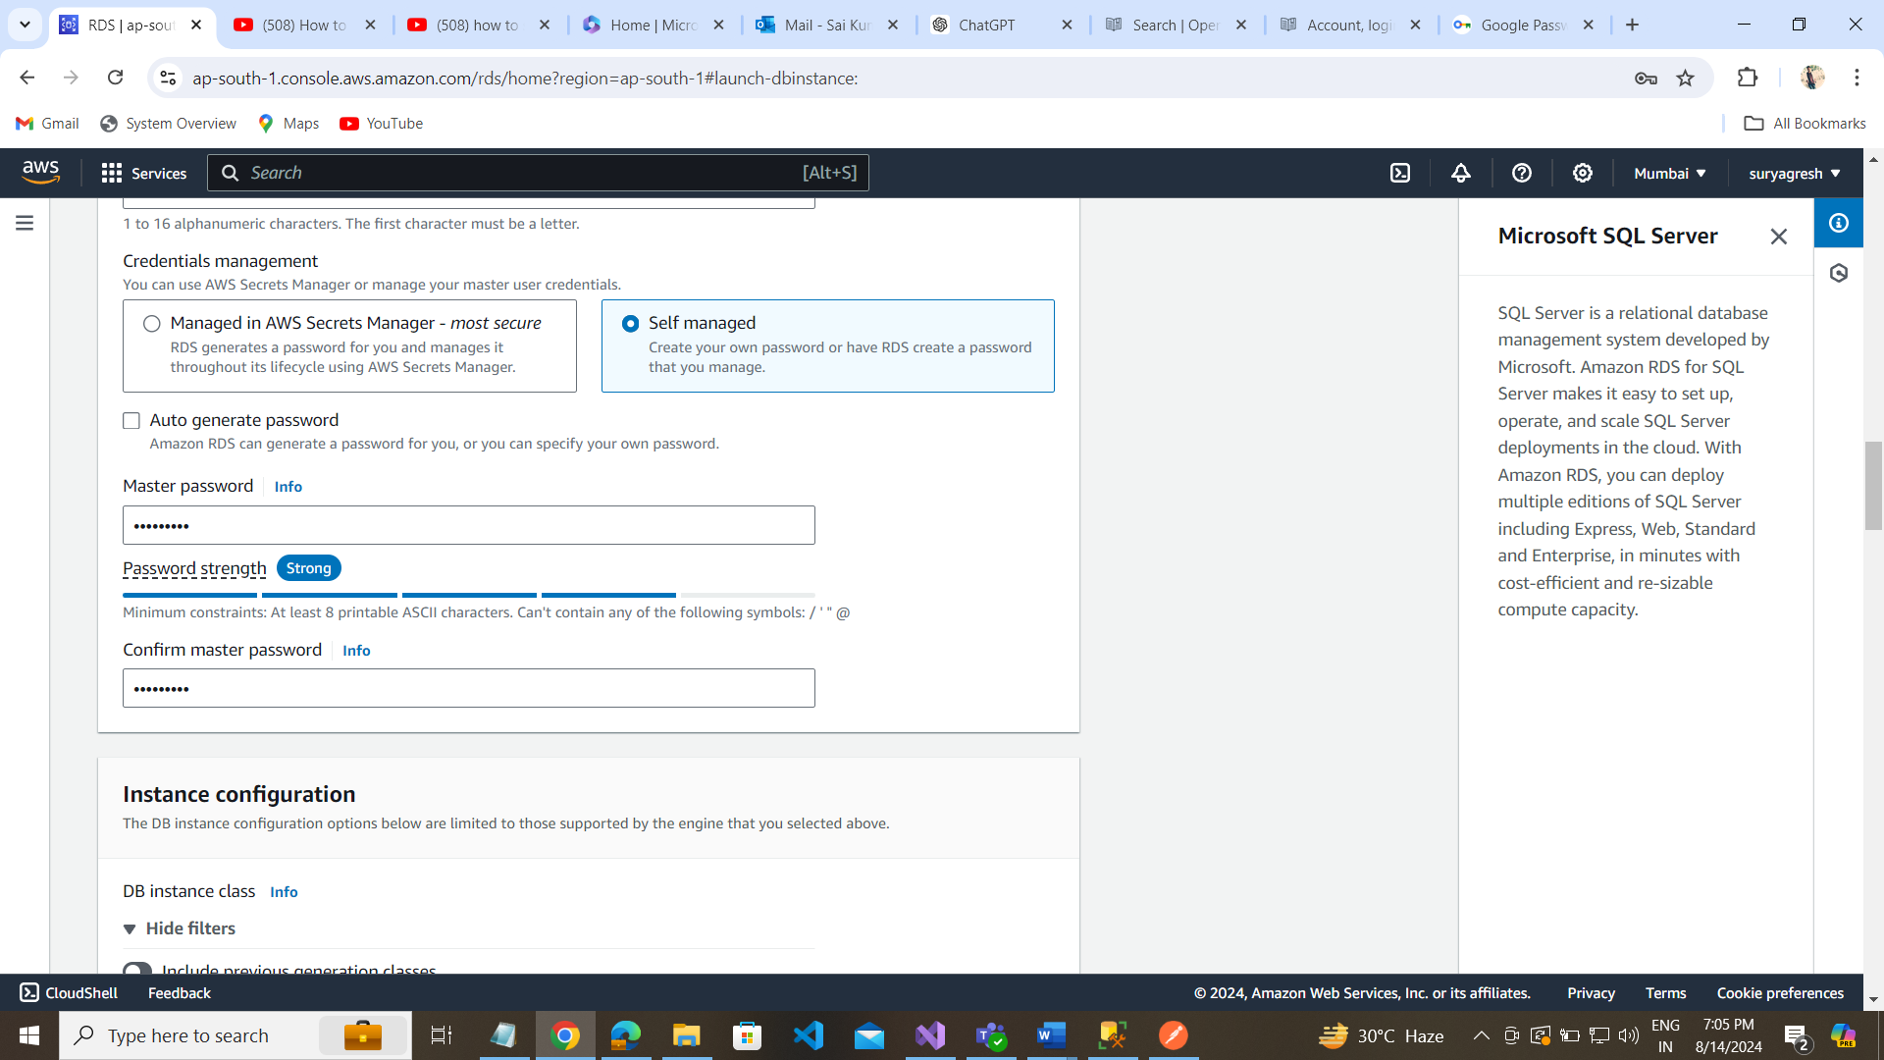

Instance configuration: db.m5.large, 100

Storage: SSD (gp3)

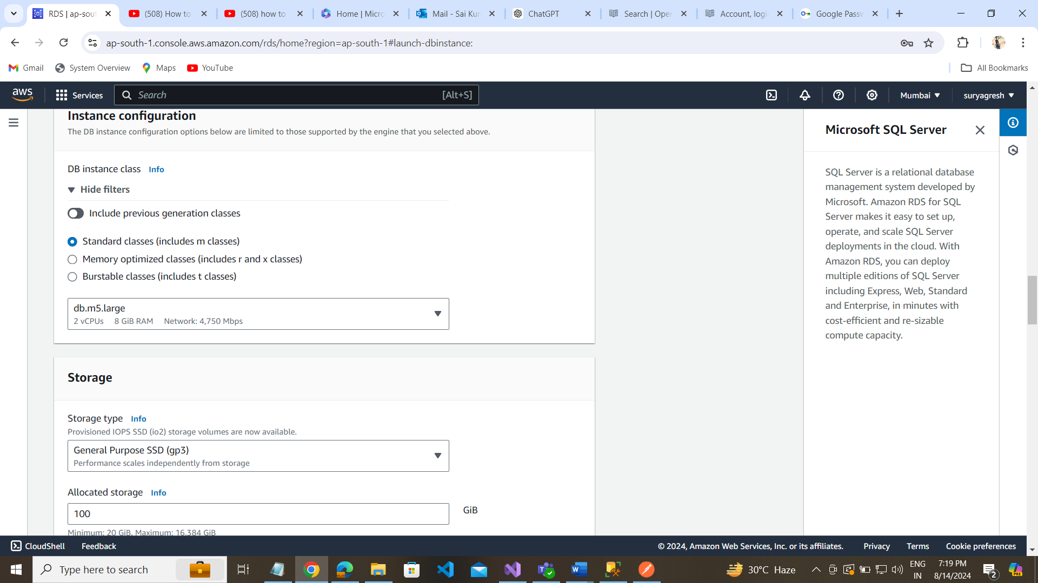

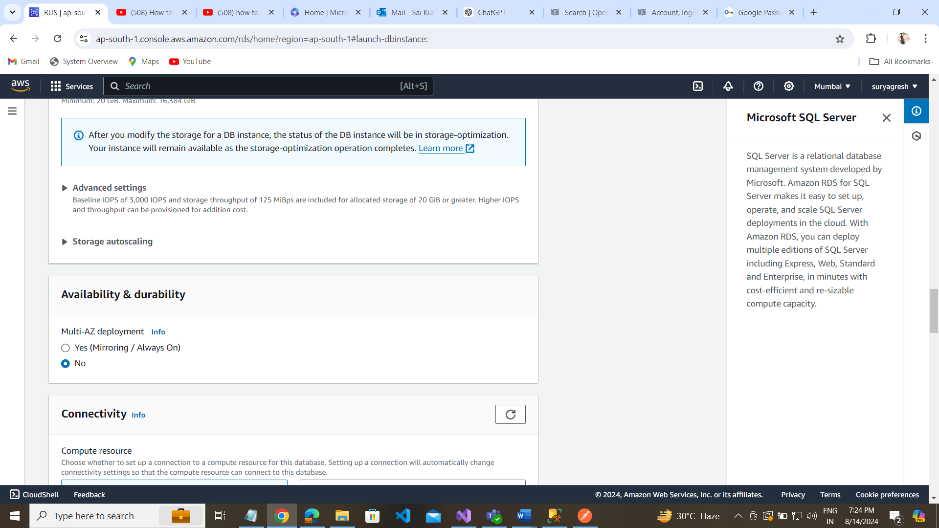

Connectvity:

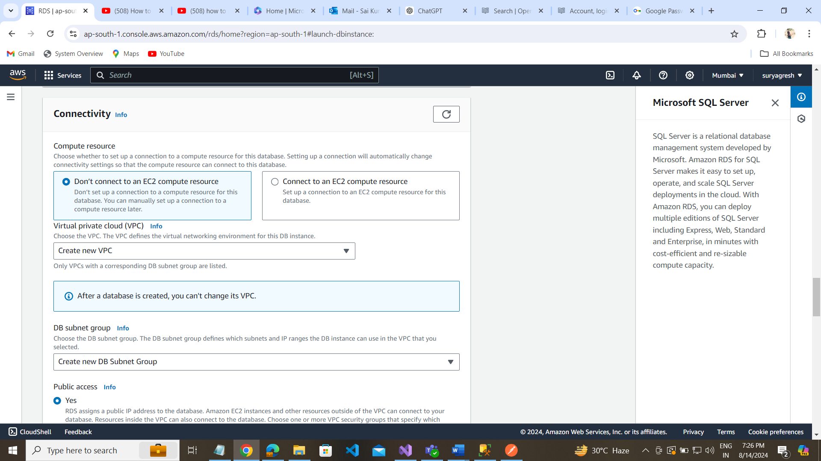

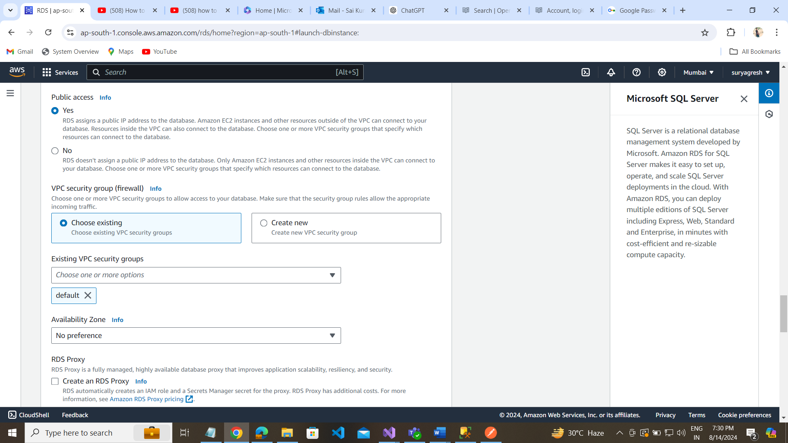

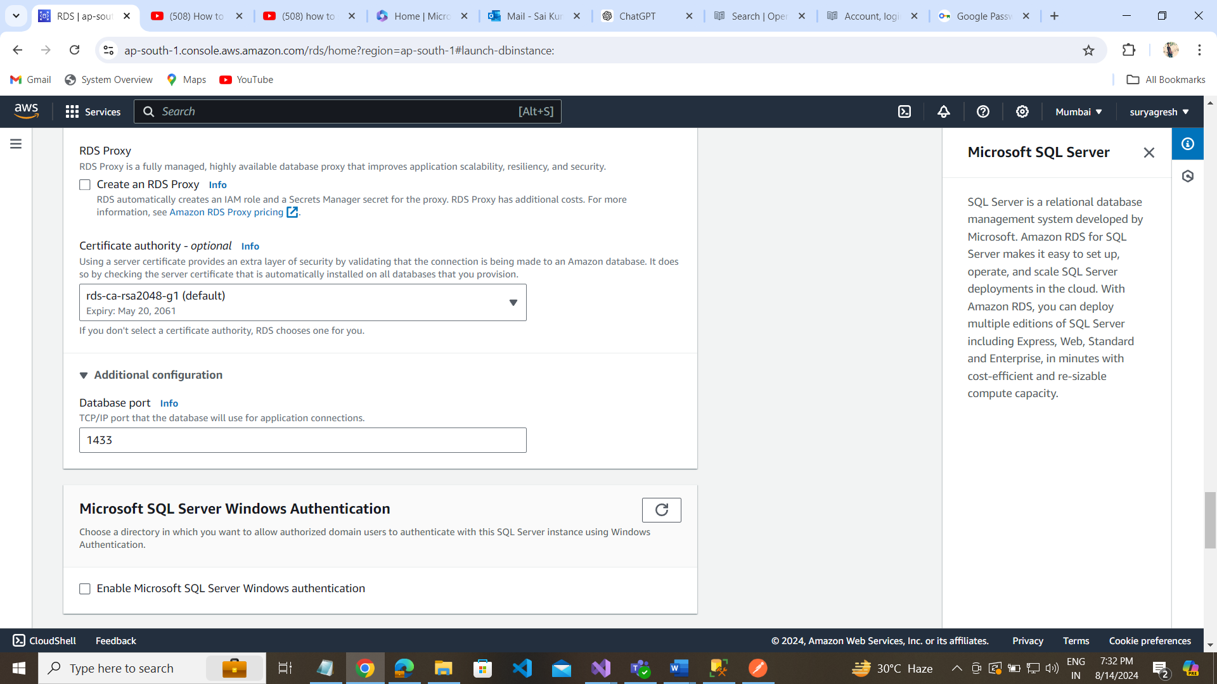

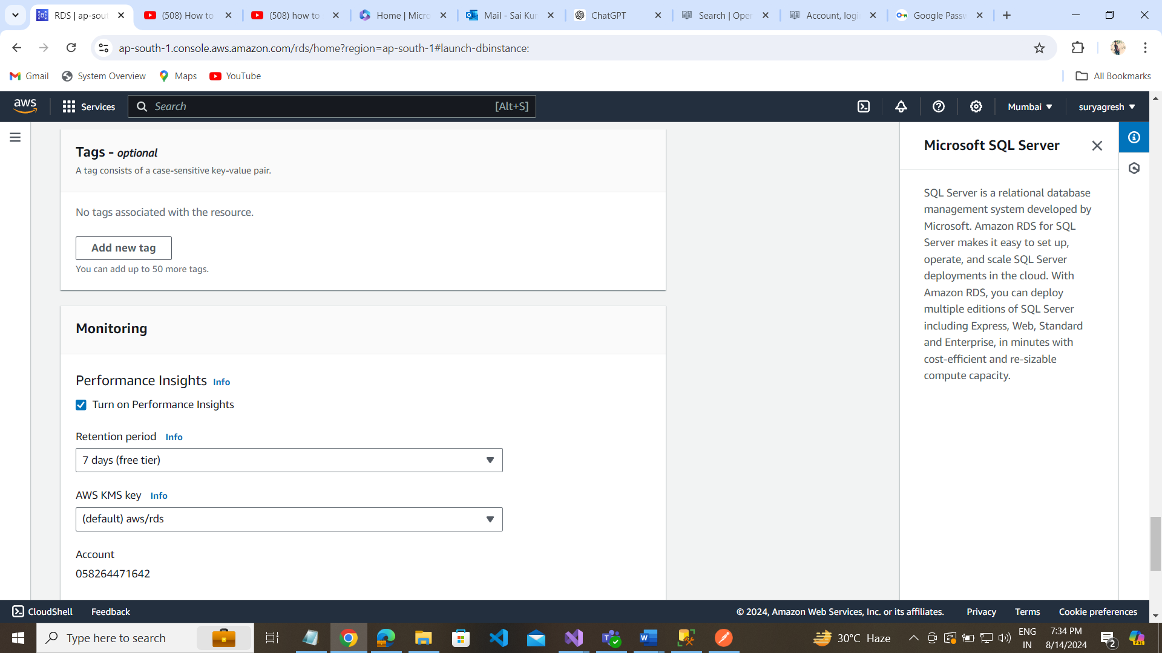

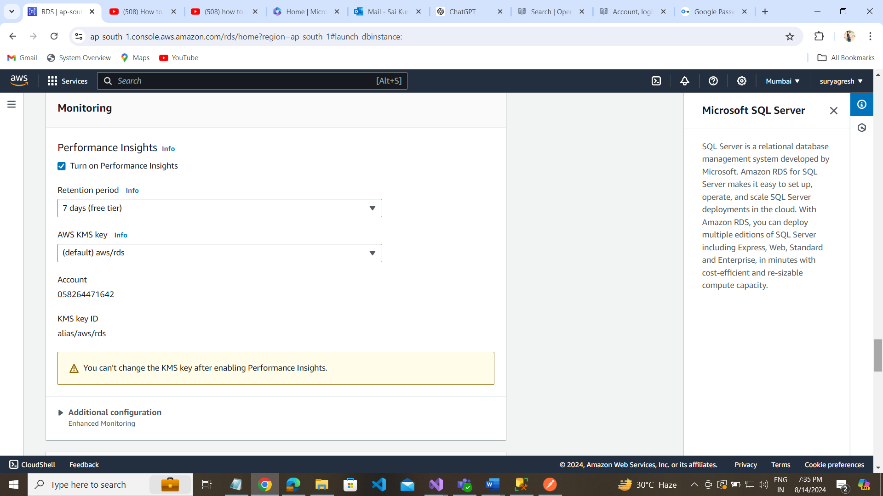

Additional Configuration:

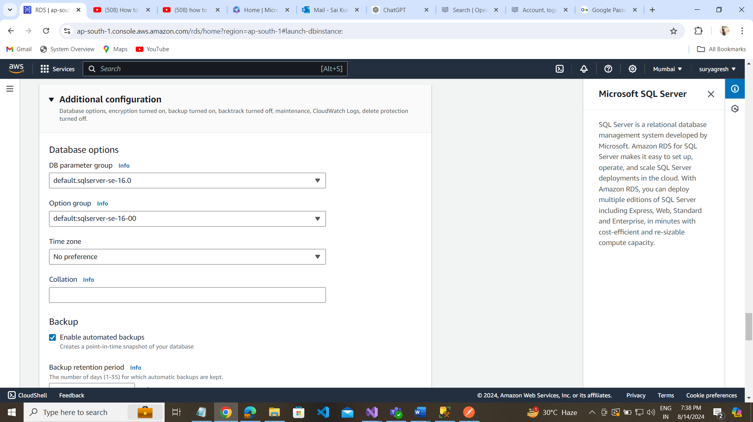

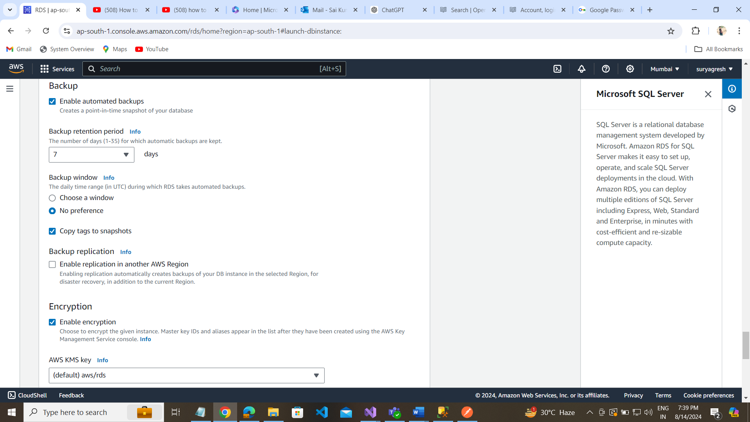

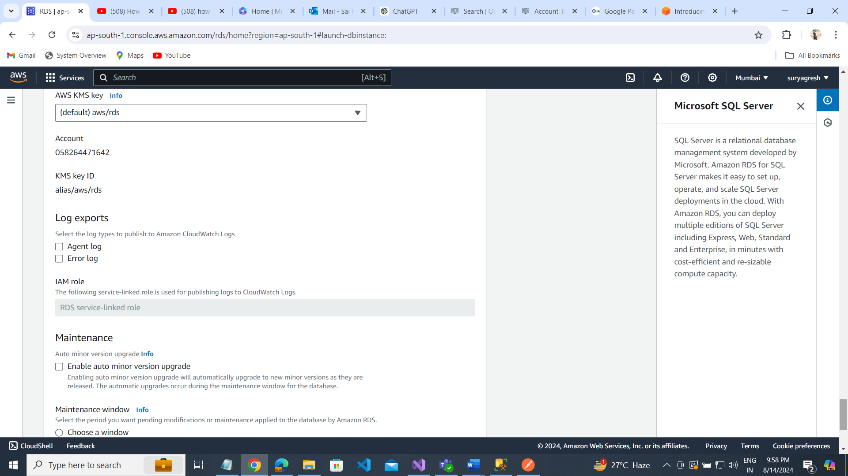

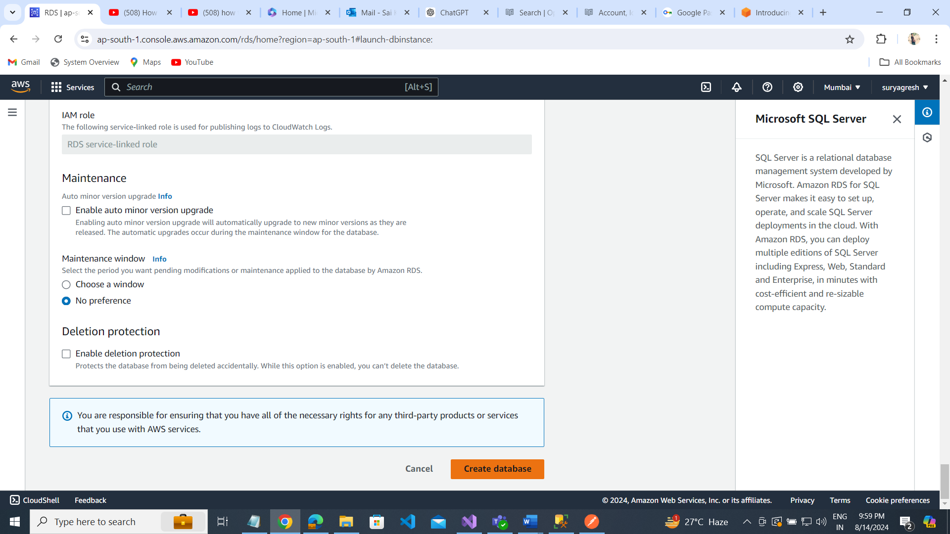

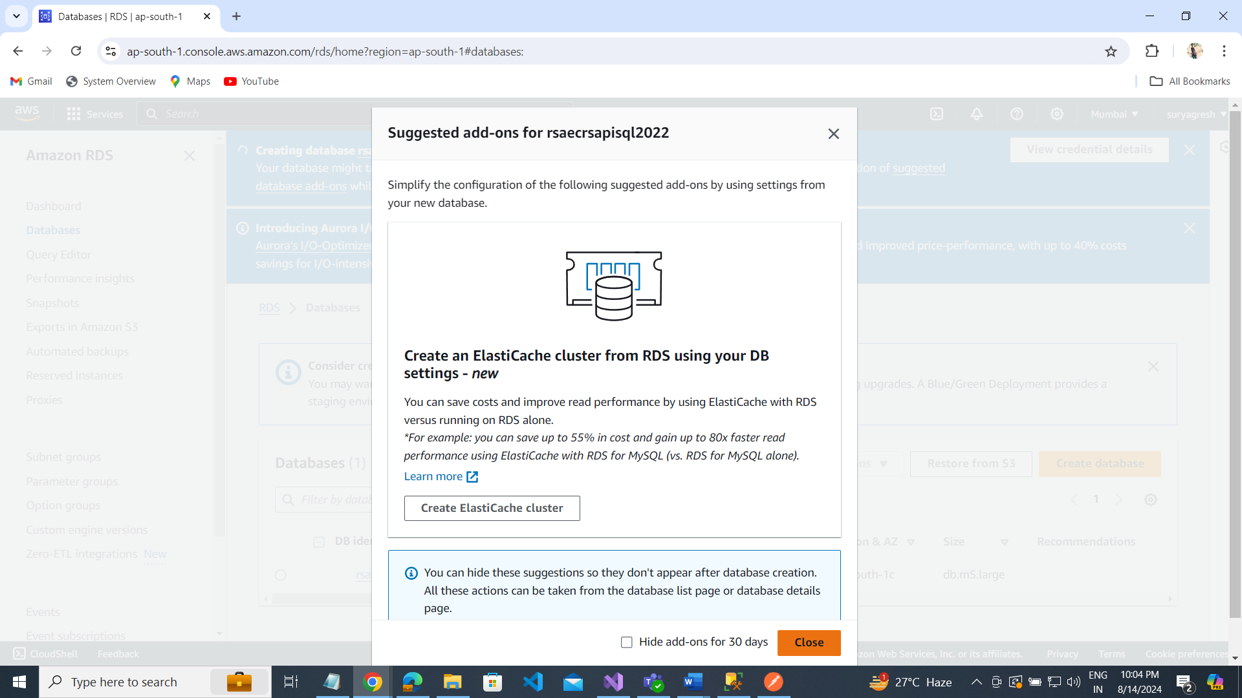

Click on close button  
Creating database

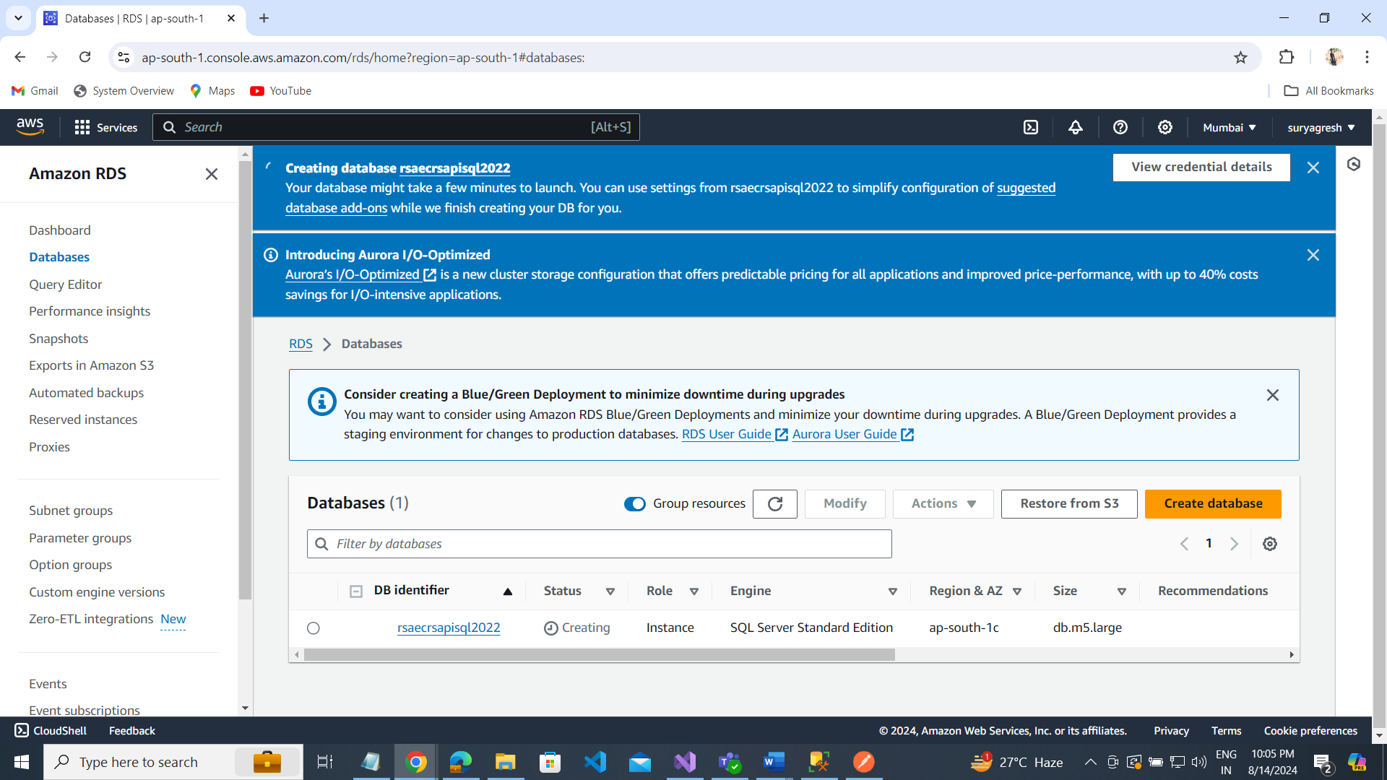

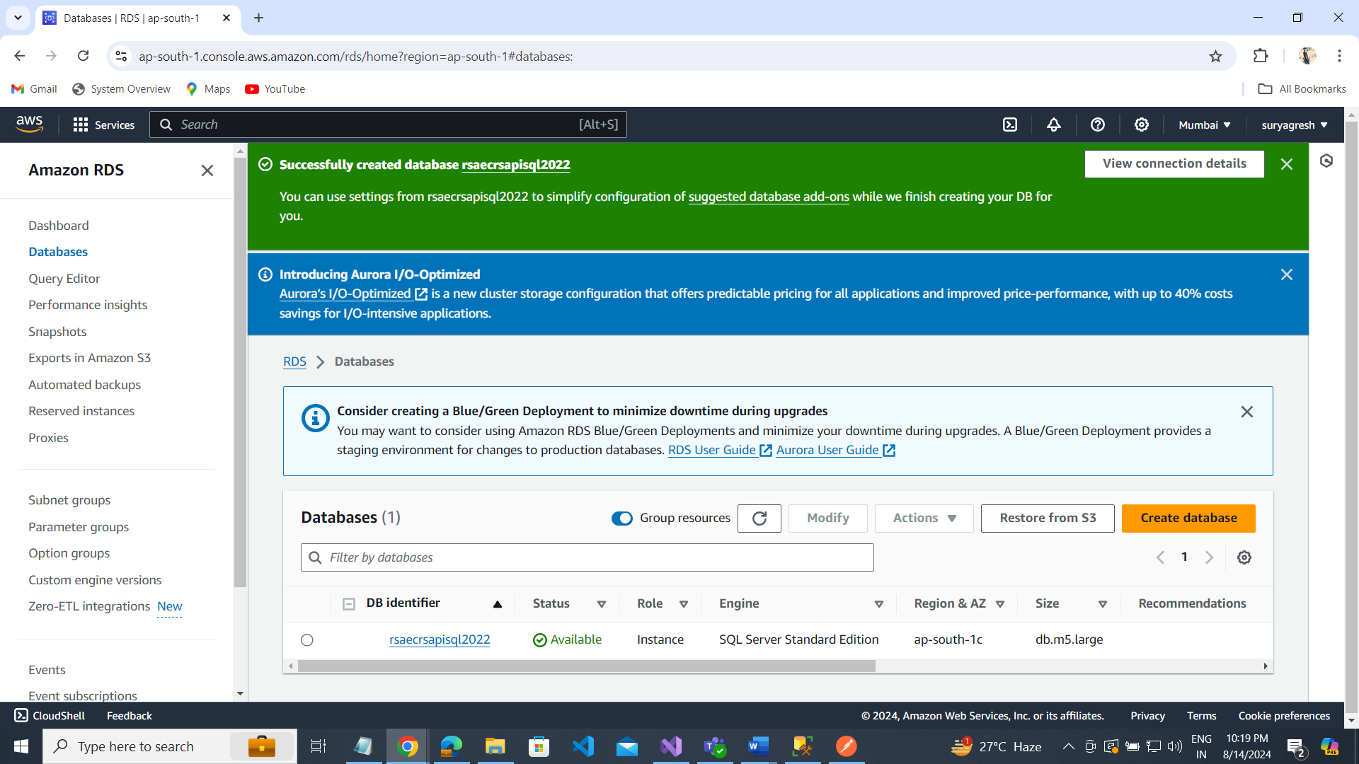

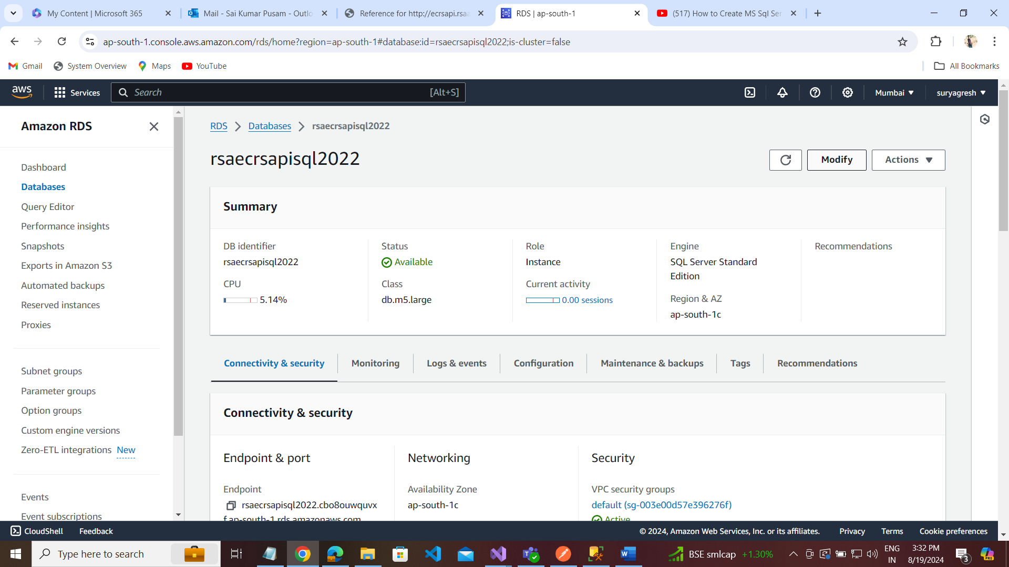

Copy the Endpoint for connecting to Sql Server database.

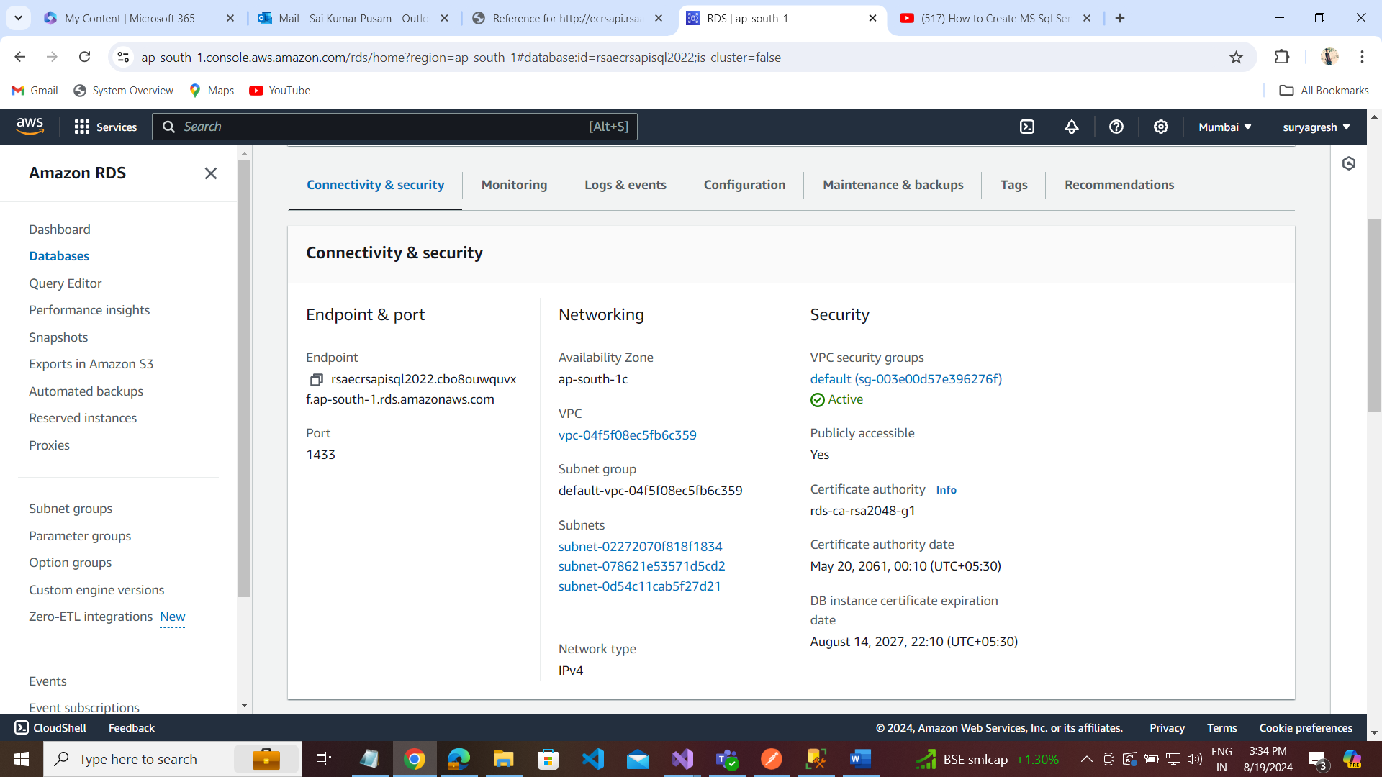

Go to Security Groups to Add custom vpc

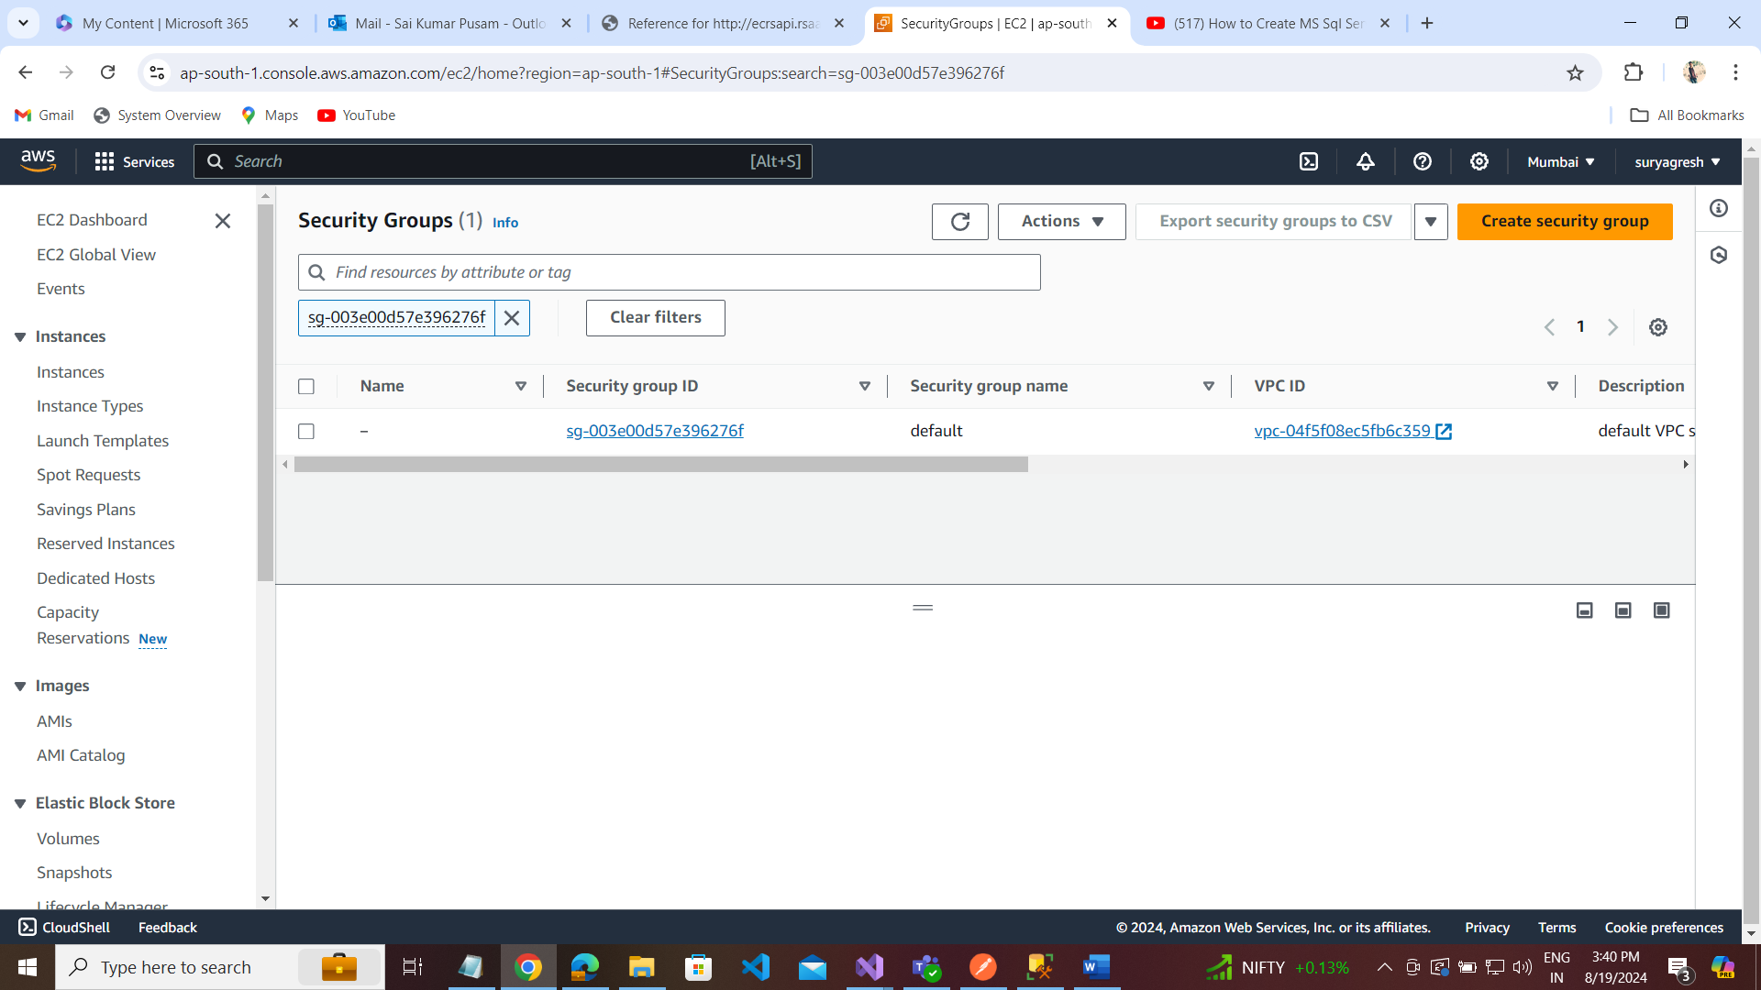

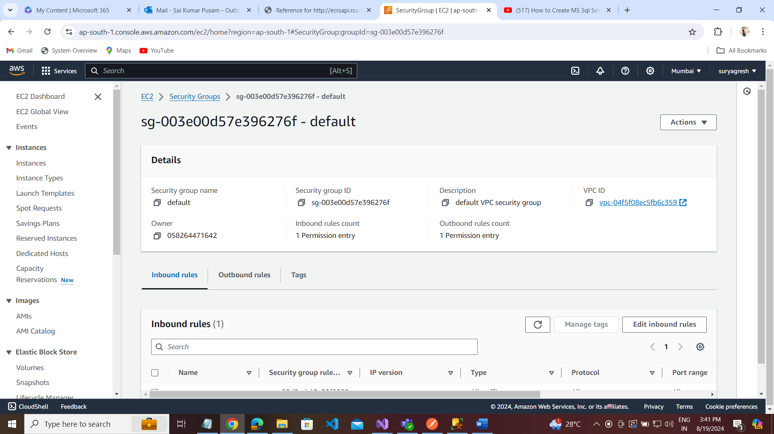

Click on Edit inbound rule to add new rule for sql connection .

Add rule with : MSSQL ----- MyIP and save rules

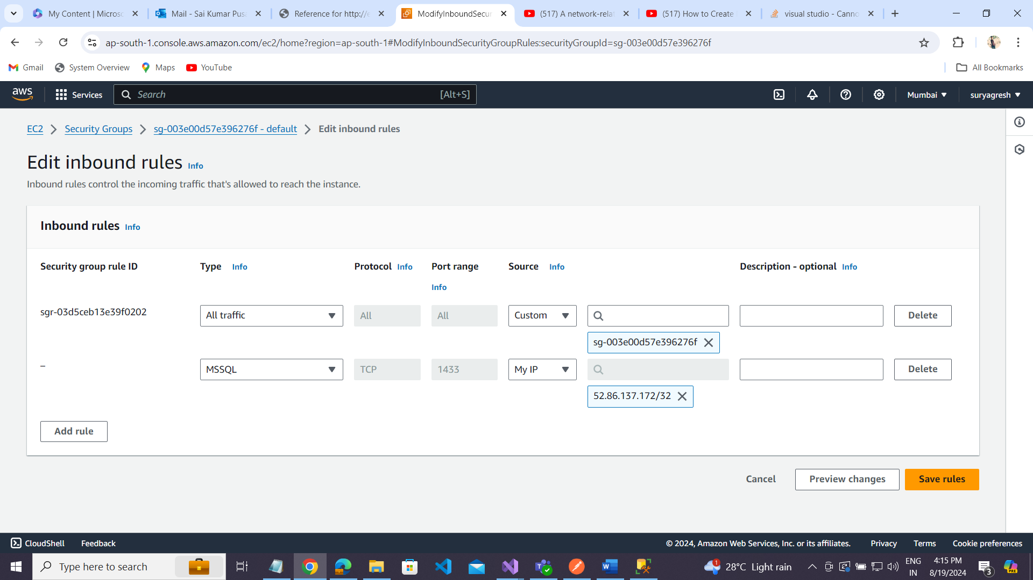

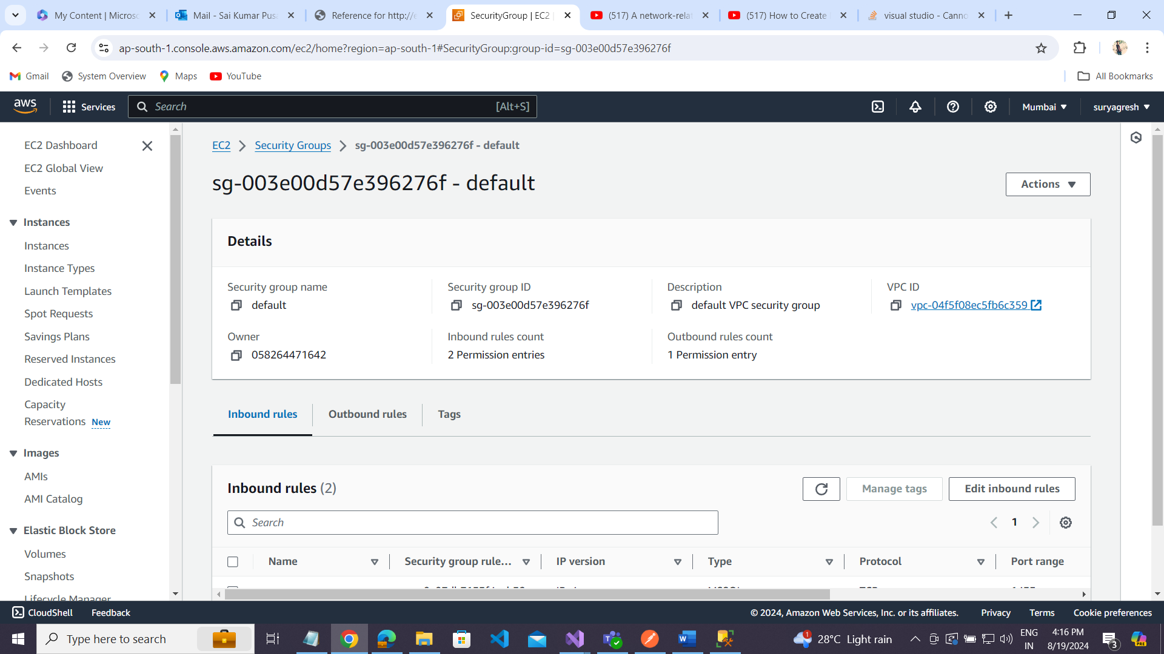

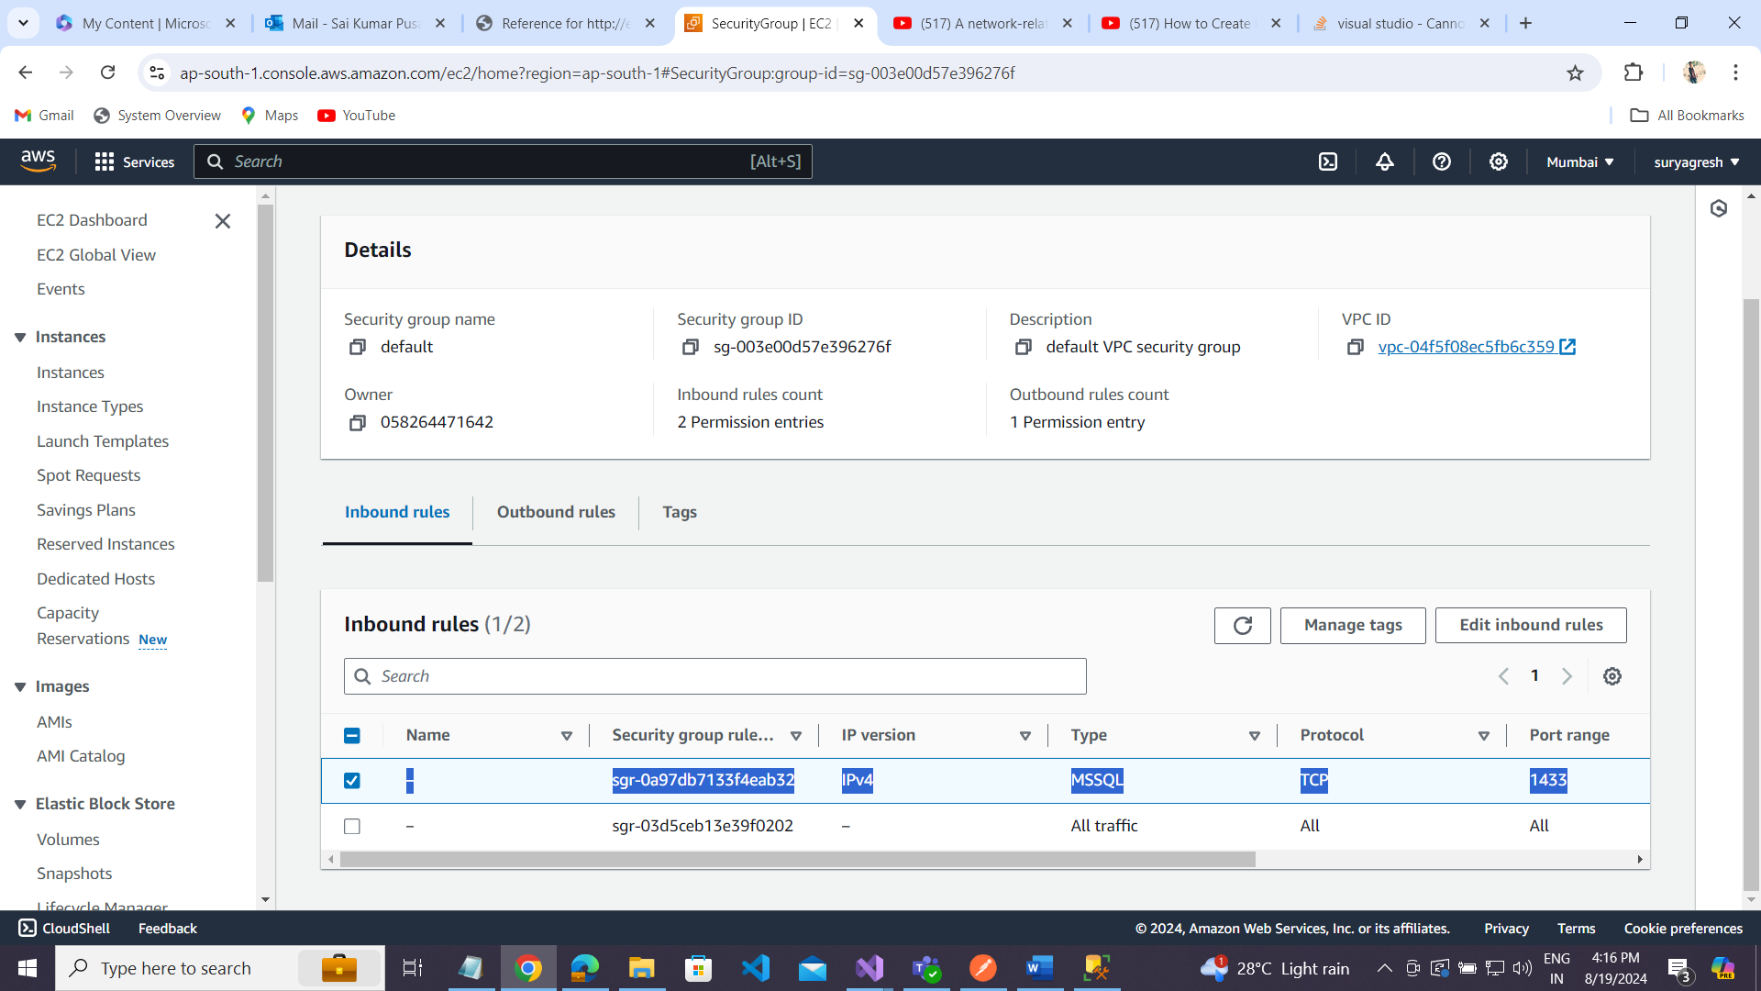

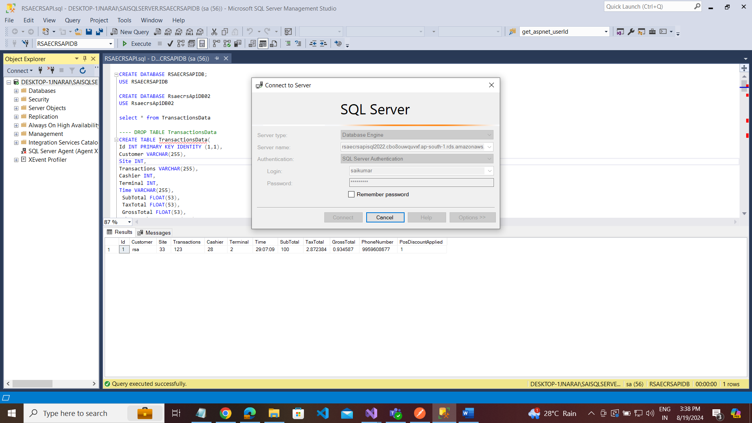

Go to Your ASP.NET CORE 8.0 WEB API Project

Appsettings.json: Add connection string for Amazon RDS SQL Server

{

"Logging": {

"LogLevel": {

"Default": "Information",

"Microsoft.AspNetCore": "Warning"

}

},

"AllowedHosts": "*",

"ConnectionStrings": {

// "RSAECRSAPIDBCon": "Server=DESKTOP-1JNARAI\\SAISQLSERVER;Database=RSAECRSAPIDB;User Id=sa;Password=sai123;Integrated Security=False;MultipleActiveResultSets=true;TrustServerCertificate=True;Encrypt=False"

//"RSAECRSAPIDBCon": "Data Source=DESKTOP-1JNARAI\\SAISQLSERVER;Initial Catalog=RSAECRSAPIDB;User ID=sa;Password=sai123"

// "RSAECRSAPIDBCon": "Data Source=DESKTOP-1JNARAI\\SAISQLSERVER;Initial Catalog=RSAECRSAPIDB;uid=sa;Password=sai123"

// connect for Amazon RDS server:

"RSAECRSAPIDBCon": "Data Source=rsaecrsapisql2022.cbo8ouwquvxf.ap-south-1.rds.amazonaws.com;Initial Catalog=RDSDemo;uid=saikumar;Password=saikumarP123"

},

// AWS Region

"AWS": {

"Region": "ap-south-1"

}

}

StartUp.cs:

using Amazon.S3;

using RSAECRSAPI.ECRSBLL;

using RSAECRSAPI.ECRSDAL;

using RSAECRSAPI.ECRSDAL.Models;

namespace RSAECRSAPI

{

public class StartUp

{

//private readonly IConfiguration _configuration;

public IConfiguration configRoot { get; set; }

// constructor

public StartUp(IConfiguration configuration)

{

configRoot = configuration;

}

// configure services

public void ConfigureServices(IServiceCollection services)

{

//var path = Environment.CurrentDirectory;

var path = Path.Combine(Environment.CurrentDirectory, @"");

IConfiguration config = new ConfigurationBuilder()

.SetBasePath(path)

.AddJsonFile("AppConfigurations.json")

.Build();

var configSettings = config.Get<AppConfigurations>();

services.Configure<AppConfigurations>(config);

services.AddScoped<ITransactionService , TransactionService>();

services.AddScoped<ITransactionRepo, TransactionRepo>();

services.AddDataProtection();

services.AddMvc();

services.AddControllers();

services.AddSwaggerGen();

services.AddHttpContextAccessor();

// Configure AWS

services.AddDefaultAWSOptions(configRoot.GetAWSOptions());

services.AddAWSService<IAmazonS3>();

}

public void Configure(WebApplication app, IWebHostEnvironment env)

{

if (app.Environment.IsDevelopment())

{

app.UseSwagger();

app.UseSwaggerUI();

}

app.UseRouting();

// add cors

//app.UseCors(c => c.AllowAnyHeader().AllowAnyOrigin().AllowAnyMethod());

app.UseHttpsRedirection();

app.UseAuthentication();

app.UseAuthorization();

app.MapControllers();

app.Run();

}

}

}

Set region for AWS Explorer: select AWS Explorer

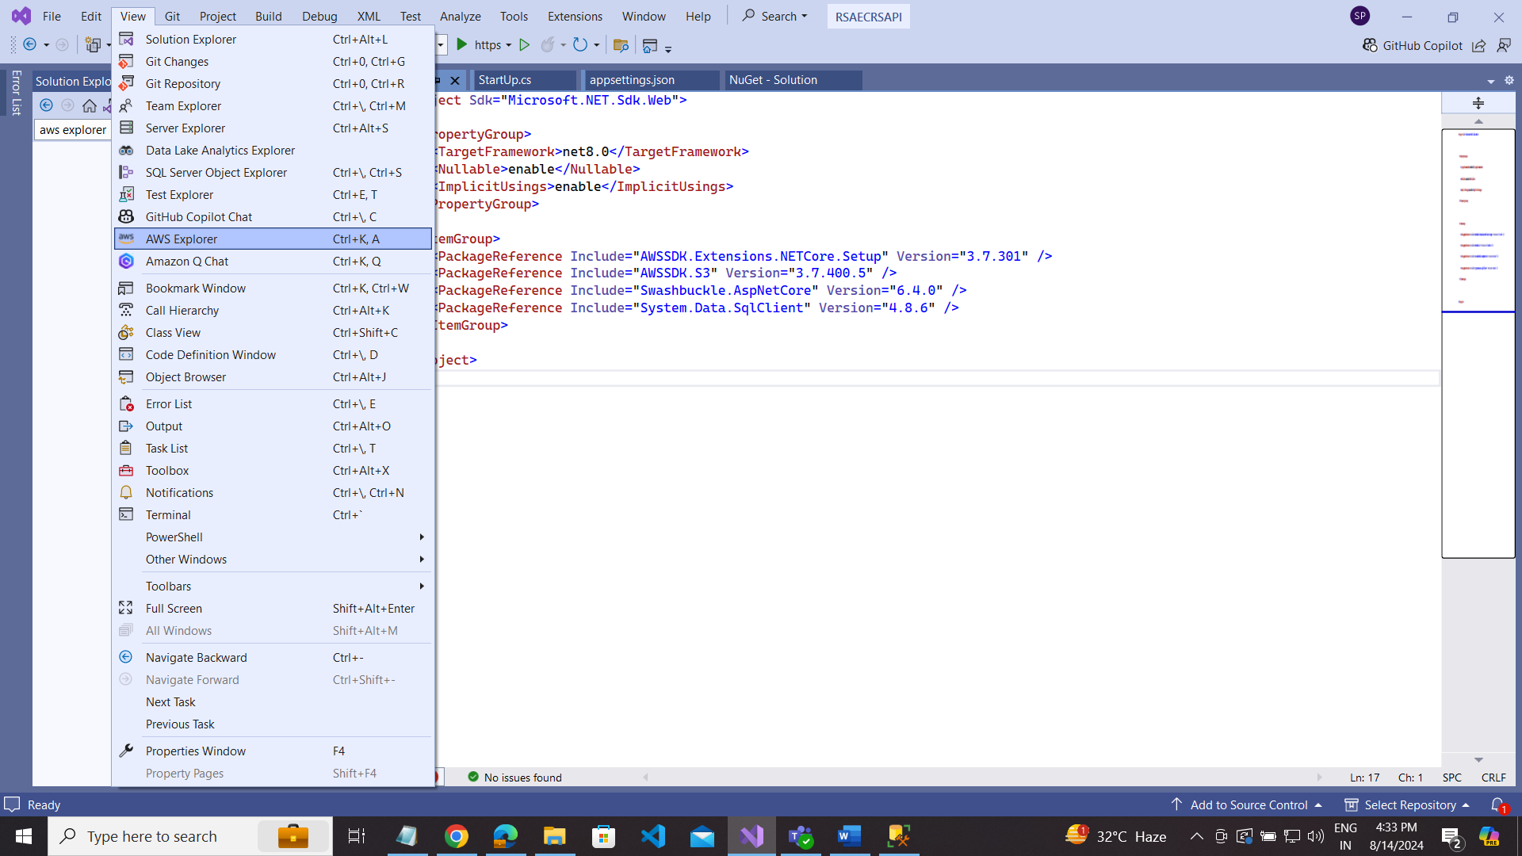

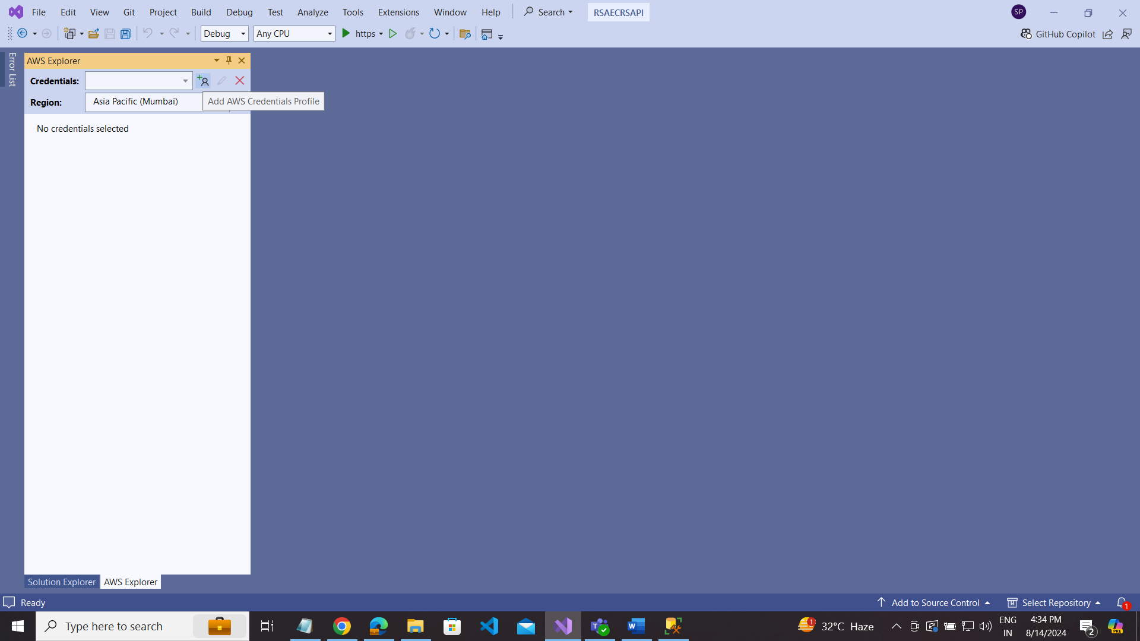

Click on the + symbol

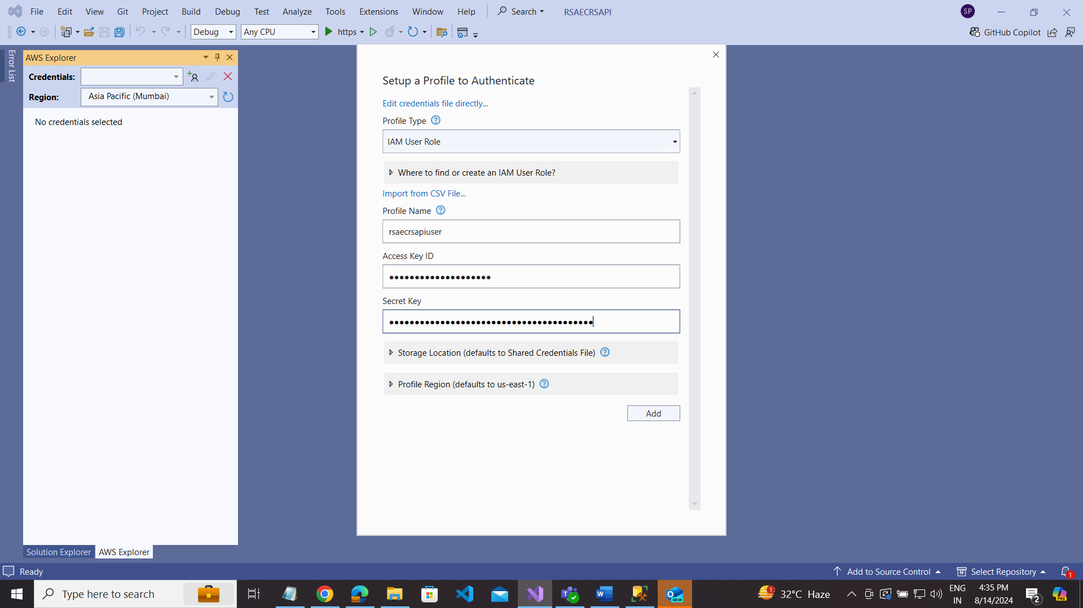

Select your elastic beanstalk server based on your region(ap-south-1) Asia Pecific (Mumbai):

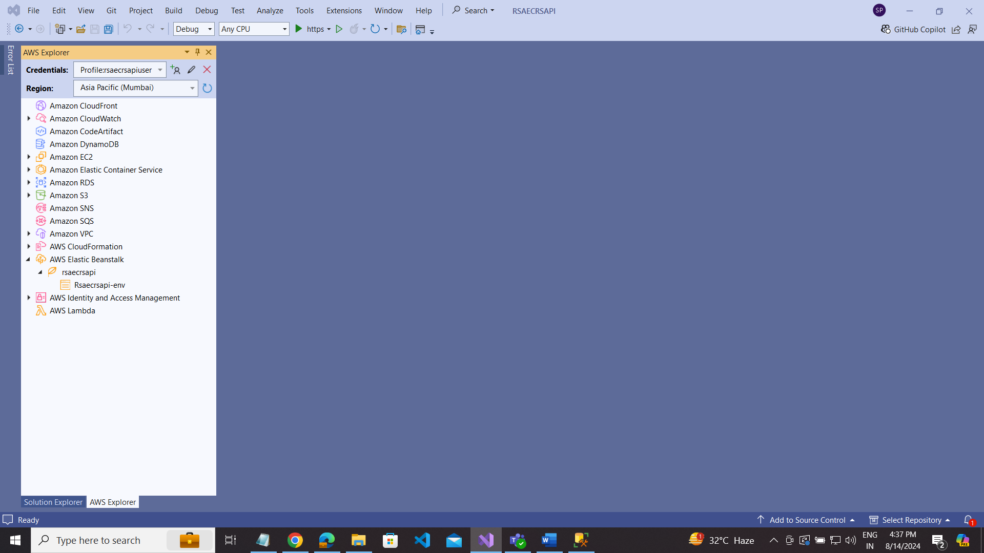

Go to your project Name ----- right click --- publish aws:

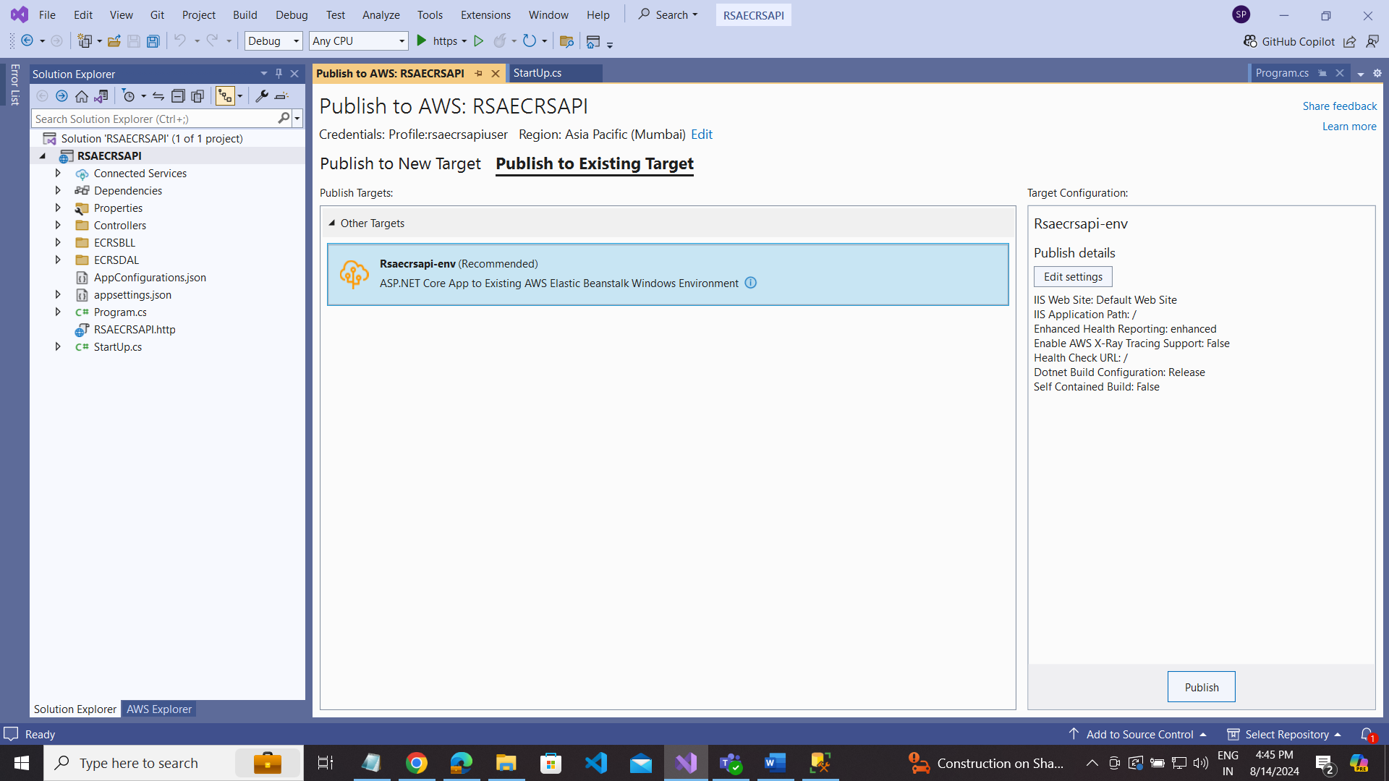

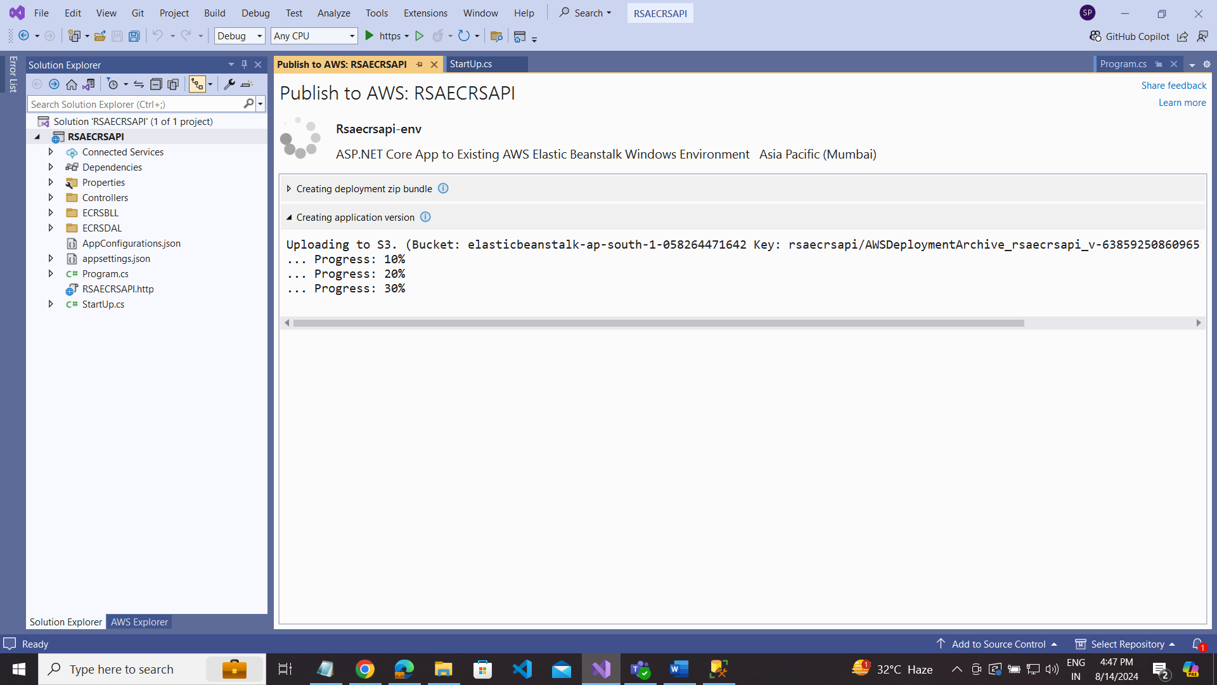

Successfully published use end point link

<https://rsaecrsapi-env.eba-ck4h3igm.ap-south-1.elasticbeanstalk.com/>

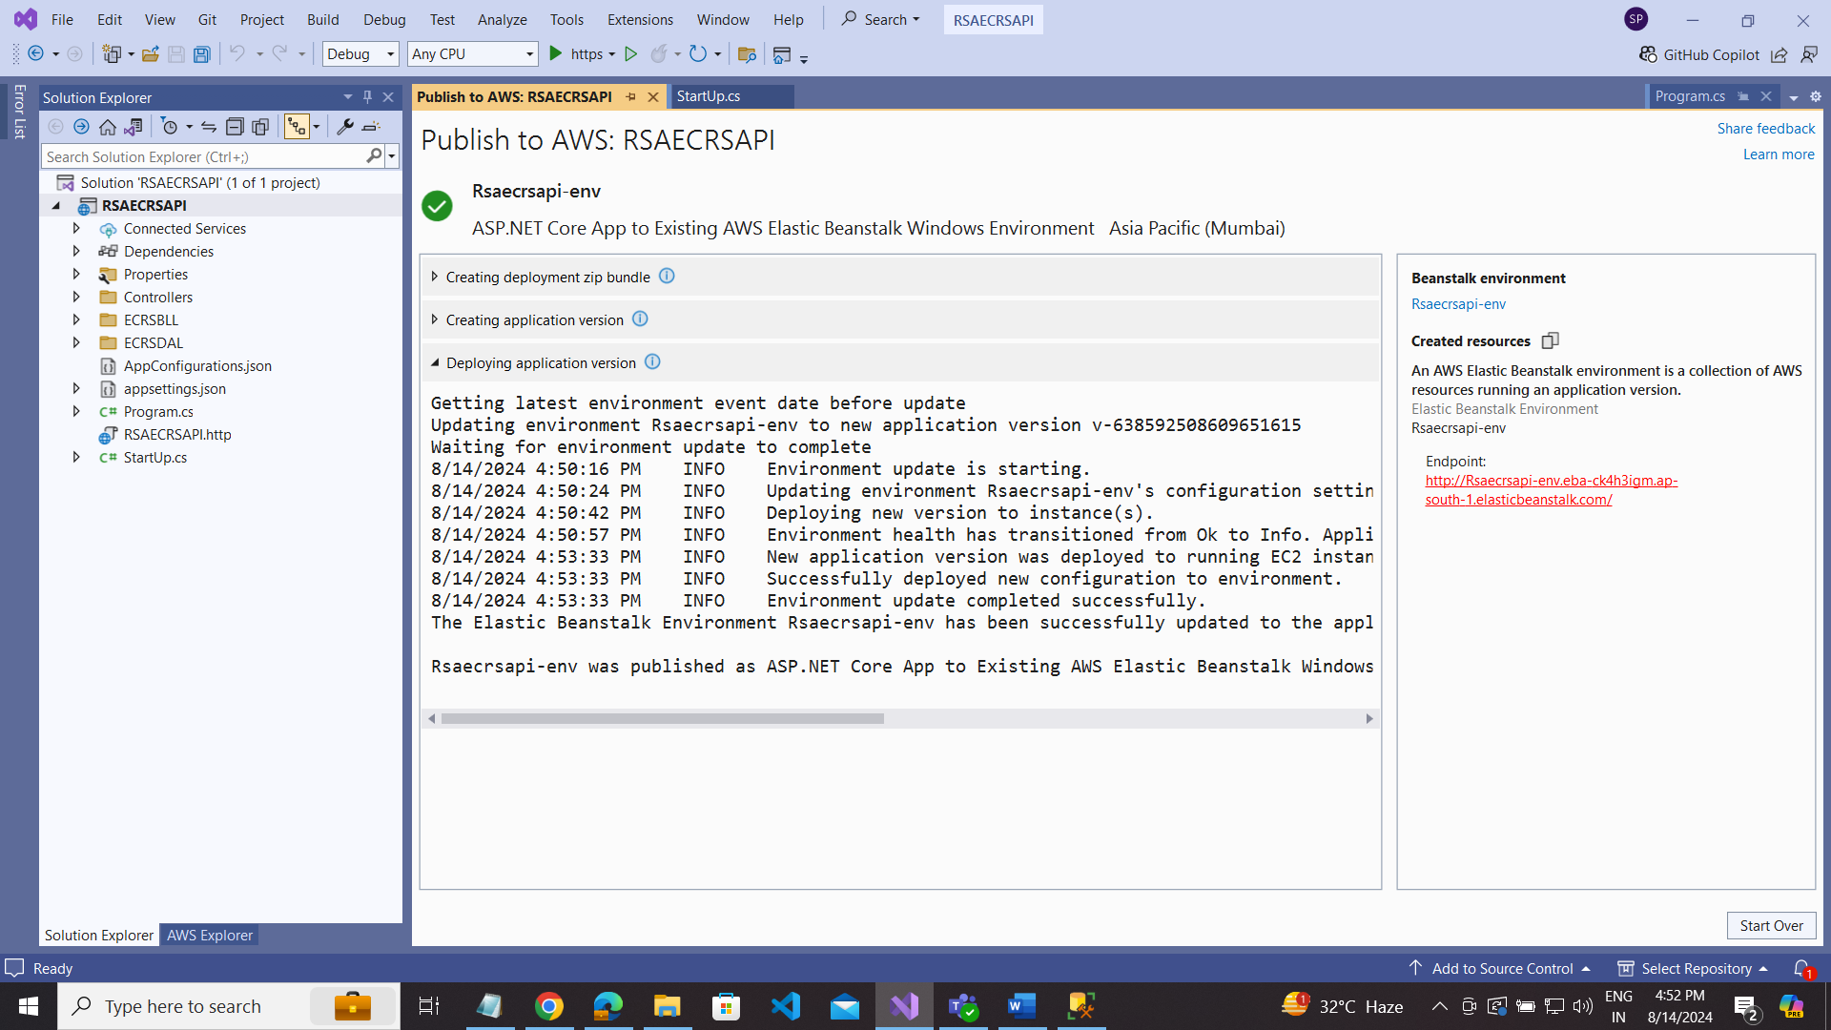

url: [rsaecrsapirds-env.eba-k2degmte.ap-south-1.elasticbeanstalk.com/ECRS/transaction/cancel?site=34985&customer=384&transaction=9988&sharedkey=9583&secretKey=093458](http://rsaecrsapirds-env.eba-k2degmte.ap-south-1.elasticbeanstalk.com/ECRS/transaction/cancel?site=34985&customer=384&transaction=9988&sharedkey=9583&secretKey=093458)

